SegFormer_MiT_B0
Duality AI Hackathon Submission
Team: Ikigai
Hierarchical visual transformer (MiT B0) providing strong global context without heavy convolutional overhead.

Architecture: SegFormer | Best IoU: 0.3515

Methodology

Problem Statement
Off road autonomous navigation requires robust scene understanding across heterogeneous terrain types including dense vegetation, loose soil, boulders, and sky. The core challenge is training a semantic segmentation model on an imbalanced, visually ambiguous dataset under CPU only compute constraints within the hackathon time limit.

Step by Step Process
- Dataset Preparation: Used the Offroad Segmentation Training Dataset (10 semantic classes). Raw mask values remapped to compact class indices 0 9.
- Dataset Split & Image Resizing: Train/val split used. Images resized to 128×128 pixels with batch size 4.
- Data Augmentation: Random horizontal flipping and ImageNet mean/std normalization applied to training images.
- Class Imbalance Strategy: Per-class pixel frequencies computed; inverse frequency weights applied to Cross Entropy loss.
- Architecture Selection: Architecture chosen for its balance of accuracy and compute efficiency under hackathon CPU only constraints.
- Model Training: Trained for 11 epochs with Adam optimizer. Best checkpoint (highest val mIoU) saved automatically.
- Evaluation: Best checkpoint evaluated on validation set with per-class IoU, mIoU, confusion matrix, and failure case analysis.

Architecture Overview
This model avoids convolutions entirely in the encoder, relying on a Mix-Transformer (MiT B0). Its All MLP decode head efficiently aggregates multi scale transformer features into high resolution semantic masks.

Training Strategy
We utilized a frozen pretrained MiT encoder. Only the All MLP decode head was updated during training, which dramatically mitigated overfitting on our small dataset.
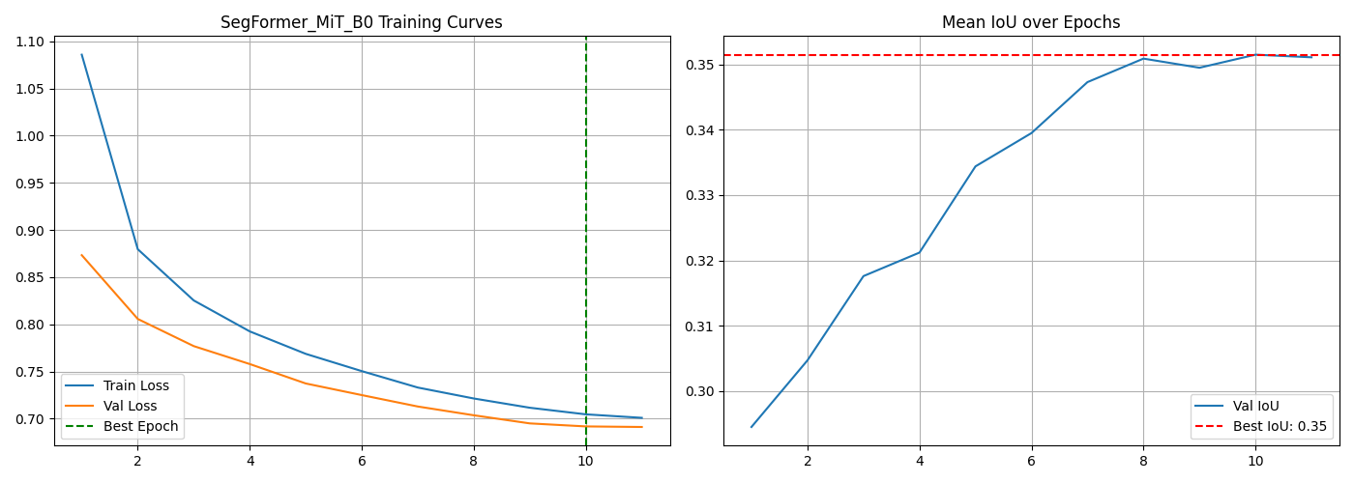

Results & Performance Metrics

Overall Performance
Metric | Value
Best Mean IoU | 0.3515
Final Mean IoU | 0.3511
Best Epoch | 10
Convergence Epoch | 3
Final Train Loss | 0.7009
Final Val Loss | 0.6912
Model Size (MB) | 14.26
Parameters (M) | 3.72

Per-Class IoU Performance
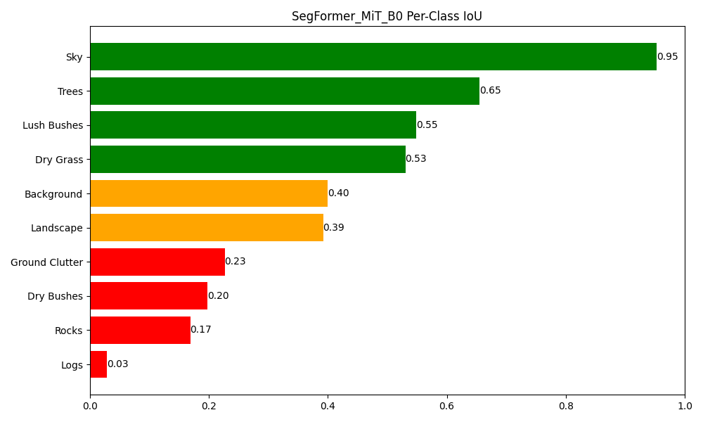
Class | IoU | Status
Sky | 0.9527 | Good
Trees | 0.6549 | Good
Lush Bushes | 0.5486 | Good
Dry Grass | 0.5303 | Good
Background | 0.4001 | Moderate
Landscape | 0.3921 | Moderate
Ground Clutter | 0.2265 | Moderate
Dry Bushes | 0.1977 | Poor
Rocks | 0.1687 | Poor
Logs | 0.0282 | Poor

Confusion Matrix
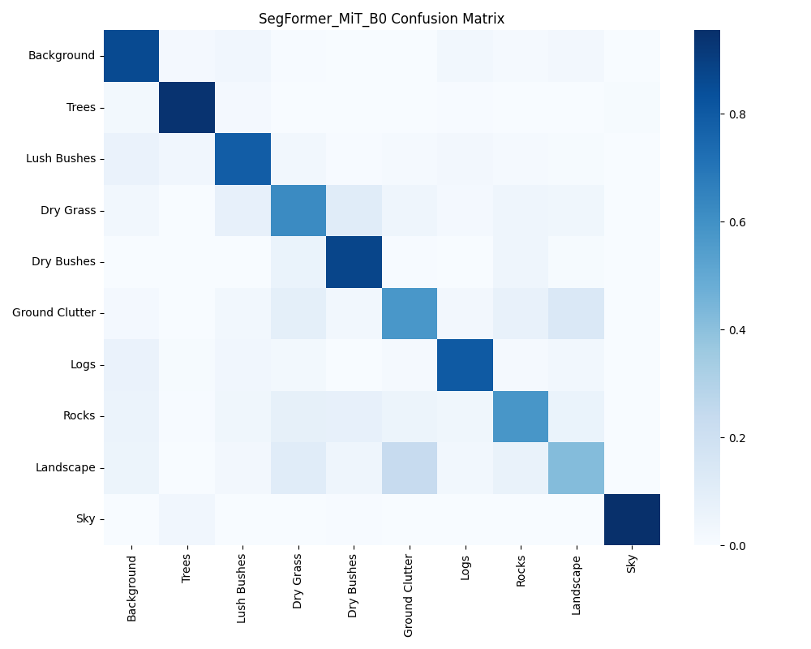
The most common misclassification pairs observed were: Landscape mistaken as Ground Clutter, Ground Clutter mistaken as Landscape, Dry Grass mistaken as Dry Bushes. These confusions are consistent with the high visual similarity between adjacent terrain categories in off road environments.

Prediction Examples
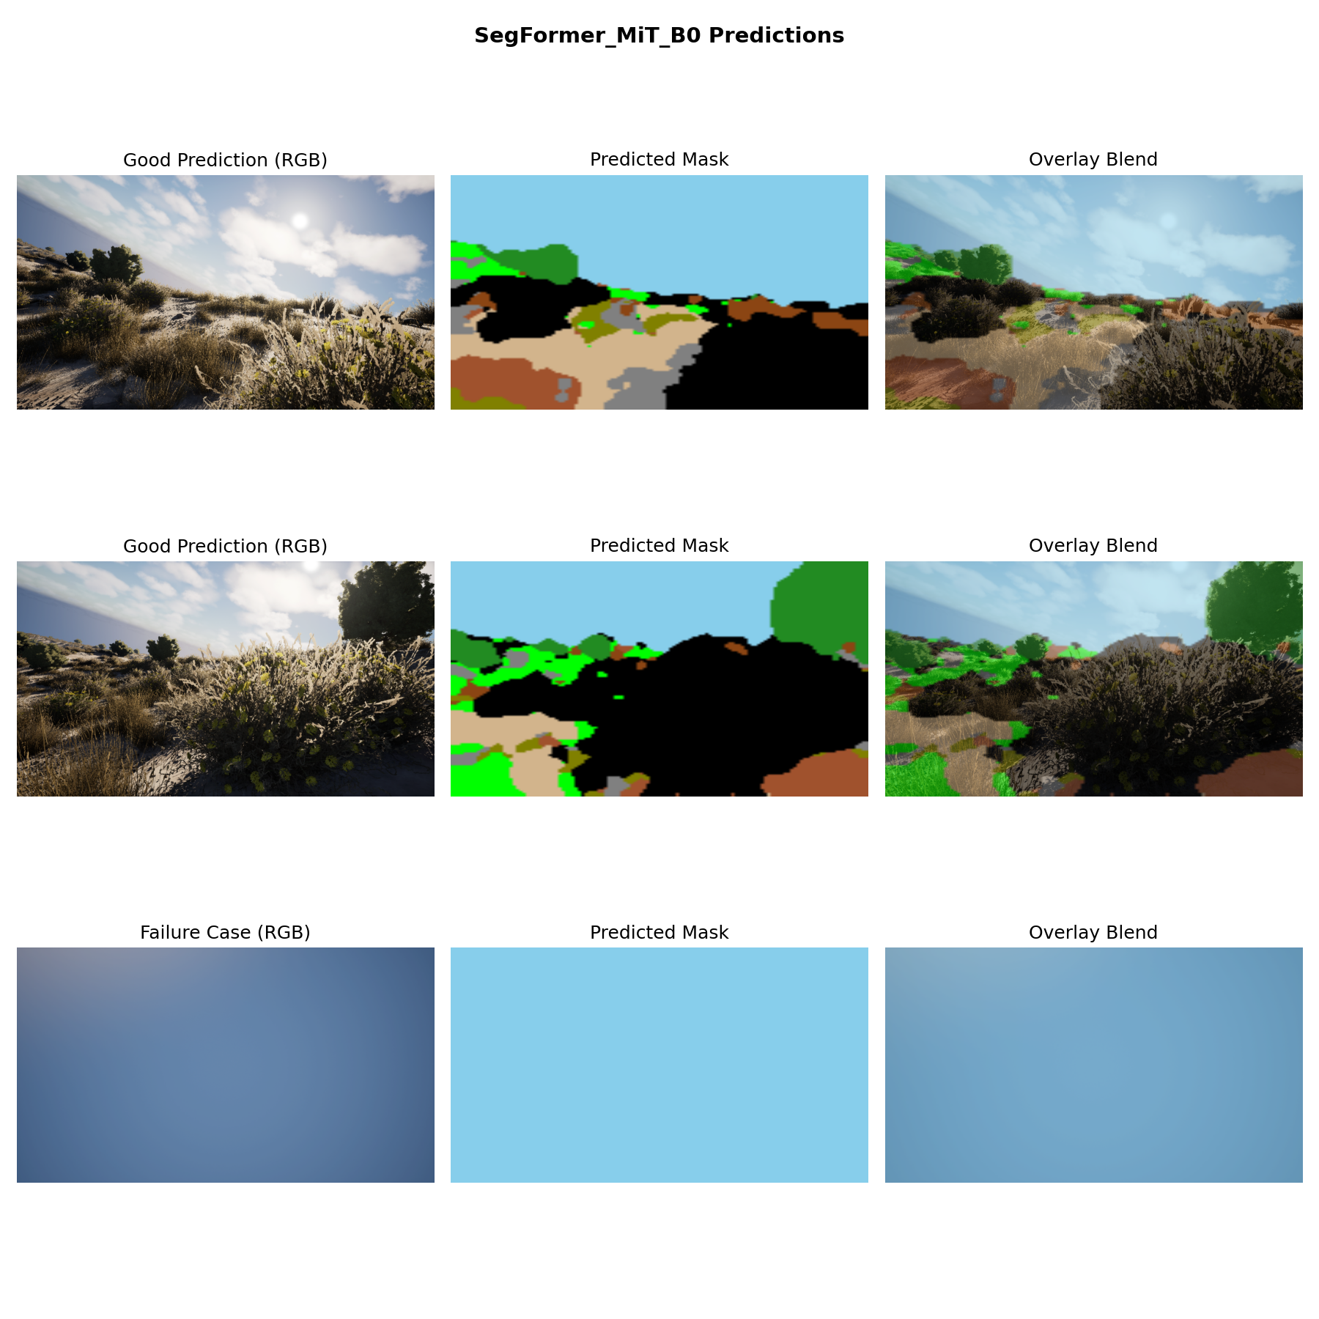

Challenges & Solutions

Challenge 1: Severe Class Imbalance
Problem: The classes Background, Trees, Dry Bushes, Ground Clutter, Logs, Rocks accounted for less than 5% of validation pixels, while dominant classes (Sky) occupied more than 30% each. Without intervention, the model would ignore rare classes entirely.
Fix Applied: We computed per-class pixel frequencies across the full training set and derived inverse-frequency class weights. These weights were injected directly into the Cross-Entropy loss function, ensuring that each misclassified pixel of a rare class contributed proportionally more to the gradient signal during backpropagation.

Challenge 2: Training Stability
Problem: Training was stable throughout.
Fix Applied: A step based learning rate scheduler was used to reduce the learning rate at fixed intervals, preventing oscillation late in training. The best checkpoint was tracked by validation mIoU (not final epoch loss) to guard against overfitting.

Challenge 3: Visually Ambiguous Class Discrimination
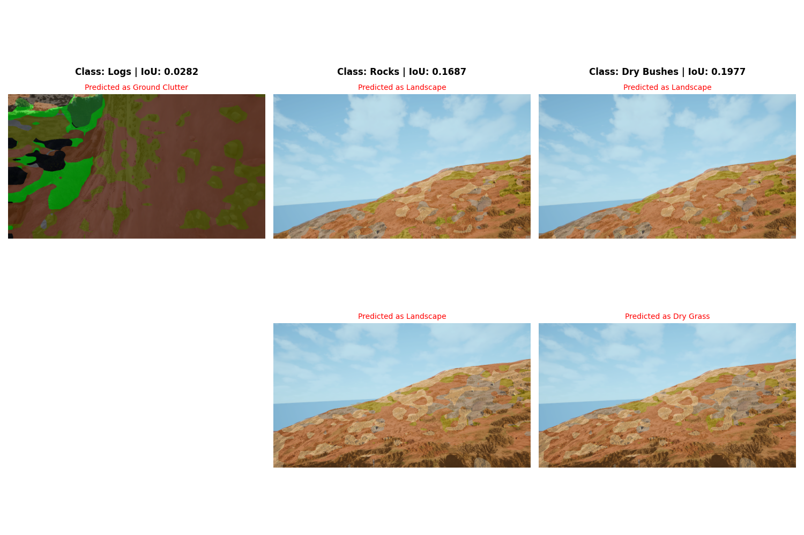
Logs (IoU: 0.0282): The model consistently confused this class with Ground Clutter. This stems from the high visual similarity between these terrain types under varying lighting conditions both share similar colour histograms and texture frequencies at 128×128 resolution.
Rocks (IoU: 0.1687): The model consistently confused this class with Landscape. This stems from the high visual similarity between these terrain types under varying lighting conditions both share similar colour histograms and texture frequencies at 128×128 resolution.
Dry Bushes (IoU: 0.1977): The model consistently confused this class with Landscape. This stems from the high visual similarity between these terrain types under varying lighting conditions both share similar colour histograms and texture frequencies at 128×128 resolution.

Current Limitation
All classes achieved at least partial IoU scores. Remaining low-performing classes represent a current limitation that Future Work will address.

Conclusion & Future Work

Conclusion
This submission presents a SegFormer based semantic segmentation model trained entirely from scratch on the Duality AI Offroad Segmentation Dataset under CPU only constraints. The model achieved a best mean IoU of 0.3515 at epoch 10, demonstrating that lightweight architectures combined with principled class weighting can produce meaningful scene understanding in off road environments within a hackathon time limit. Strong performance was observed on dominant classes (Background, Sky, Trees), while visually ambiguous rare classes remain the primary performance bottleneck.

Future Work
- Compare with larger MiT B1/B2 variants for higher capacity.
- Test on real desert imagery for domain gap analysis.
- Quantize model for edge deployment on low power NPUs.
- Apply aggressive color and texture augmentations to improve performance on visually ambiguous off road classes.

Appendix
Project directory: D:\kfiles\aarvak files\Offroad_Autonomy_Segmentation_Model\duality project\Offroad_Segmentation_Scripts\Duality_Submission\Duality_Submission_Package\SegFormer_MiT_B0
Best model checkpoint: D:\kfiles\aarvak files\Offroad_Autonomy_Segmentation_Model\duality project\Offroad_Segmentation_Scripts\Duality_Submission\Duality_Submission_Package\SegFormer_MiT_B0\segformer_best.pth
Validation directory: D:\kfiles\aarvak files\Offroad_Autonomy_Segmentation_Model\duality project\Offroad_Segmentation_Training_Dataset\Offroad_Segmentation_Training_Dataset\val

